|  |  |  |  |
| --- | --- | --- | --- |
| a_sig_horiz_2c_bk_jpg | | | |
| TITLE: | MyCardioMEMS Build Pipeline Setup Guide | ITEM NUMBER: |  |
| Document / Specification and Instruction | | REVISION: |  |

Change History

|  |  |  |
| --- | --- | --- |
| Rev | Description of Change |  |
| 1.0 | Initial Draft |  |

1. **PURPOSE**

The purpose of this document is to provide the information needed to set up

1. Build Pipeline for myCardiMEMS Android Application using Azure DevOps and generate APK from the Pipeline.
2. Integrate Unit Test, static code analysis (Still pending) and Azure Artifacts tools to build pipeline.
3. **SCOPE**

This document describes steps to set up build Pipeline for myCardioMEMS Android Application on Azure DevOps and generate APK file from the pipeline and deploying artifacts into Azure Artifacts.

1. **ASSOCIATED DOCUMENTS**
   1. APPLICABLE DOCUMENTS

|  |  |
| --- | --- |
| NUMBER | TITLE |
|  | myCardioMEMS SRS Document |

1. **SYSTEM REQUIREMENT**

This section describes hardware, network and software needed to a software build

* 1. HARDWARE REQUIRMENT

|  |  |  |  |  |
| --- | --- | --- | --- | --- |
| Component | Server Type | CPU | MEMORY | OS Disk |
| Build Machine | Azure Windows VM Version- Windows 10 Pro | 4 vCPUs | 16 GB | 127 GB and vCPU – 4 |

1. **WINDOWS BUILD MACHINE ACCOUNT REQUIREMENT**

|  |  |  |
| --- | --- | --- |
| COMPONENT | USER | ROLE |
| Windows Build Machine | testpocuser | admin |

1. **NETWORK REQUIREMENT**

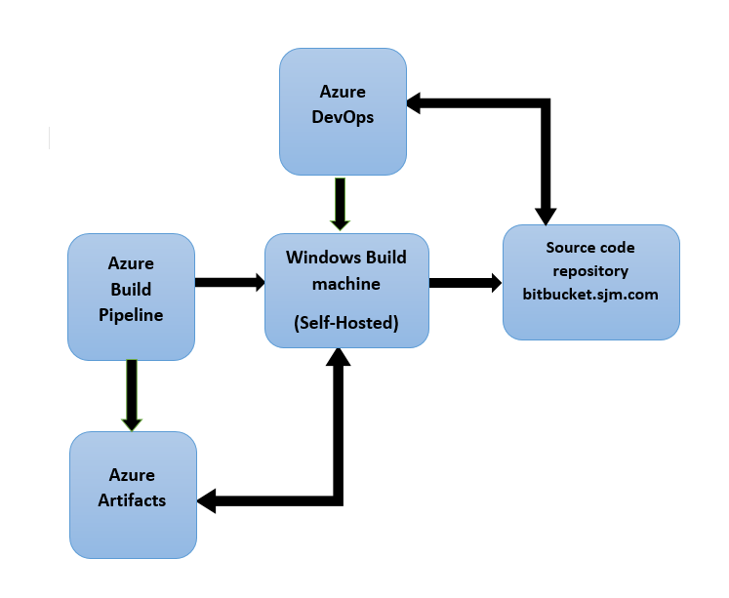

1. **SOFTWARE REQUIREMENT**

Following development tools has to be installed on Build machine as an Admin on Windows Build machine

* JAVA 11.0.13
* Gradle 7.3.3
* Android Studio

Following path need to add in Environment variables like below.

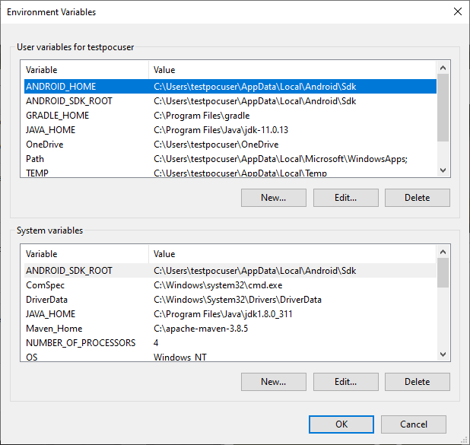

**Access to Bitbucket Repository:** Build Machine user need access to the Bitbucket repository.

[https://bitbucket.sjm.com/projects/MYC/repos/android/browse?at=refs%2Fheads%2Fdev%2Fpipeline](https://apc01.safelinks.protection.outlook.com/?url=https%3A%2F%2Fbitbucket.sjm.com%2Fprojects%2FMYC%2Frepos%2Fandroid%2Fbrowse%3Fat%3Drefs%252Fheads%252Fdev%252Fpipeline&data=05%7C01%7Cpraveenkumar_krish%40hcl.com%7Cb204f55069ed4d3f898808da2ce96dfb%7C189de737c93a4f5a8b686f4ca9941912%7C0%7C0%7C637871678344306297%7CUnknown%7CTWFpbGZsb3d8eyJWIjoiMC4wLjAwMDAiLCJQIjoiV2luMzIiLCJBTiI6Ik1haWwiLCJXVCI6Mn0%3D%7C3000%7C%7C%7C&sdata=E2cASITLDj0xBrUTfoD2zJ0fa4psNK%2BhObI73C%2FPRx0%3D&reserved=0)

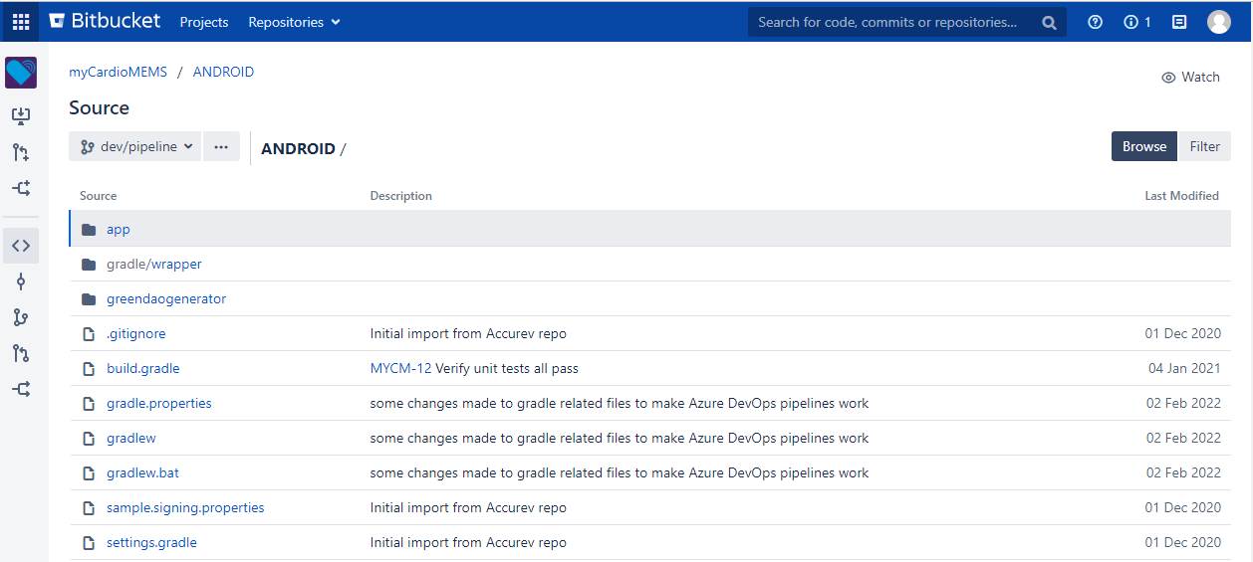

1. **BUILD WORKFLOW**

**Azure DevOps Build Pipeline**:

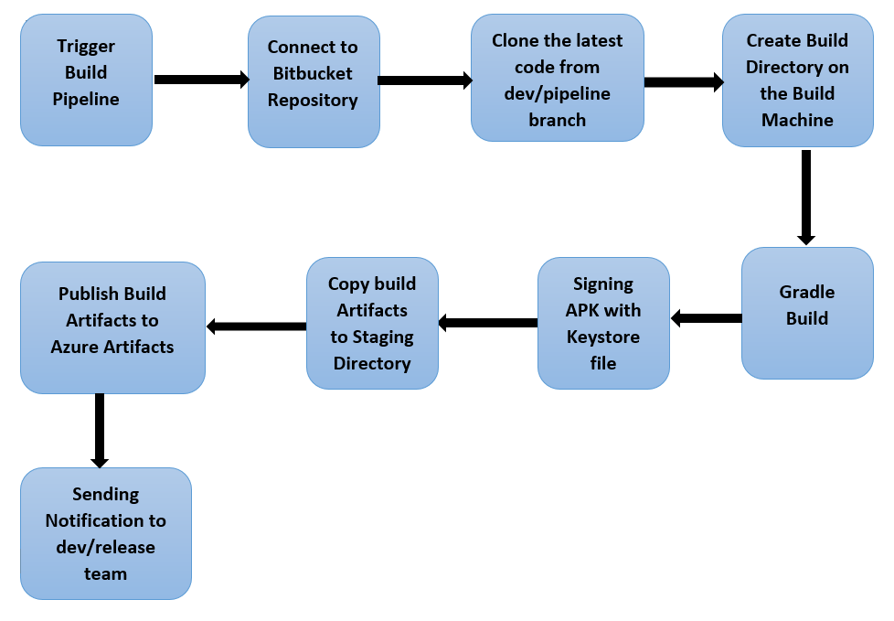

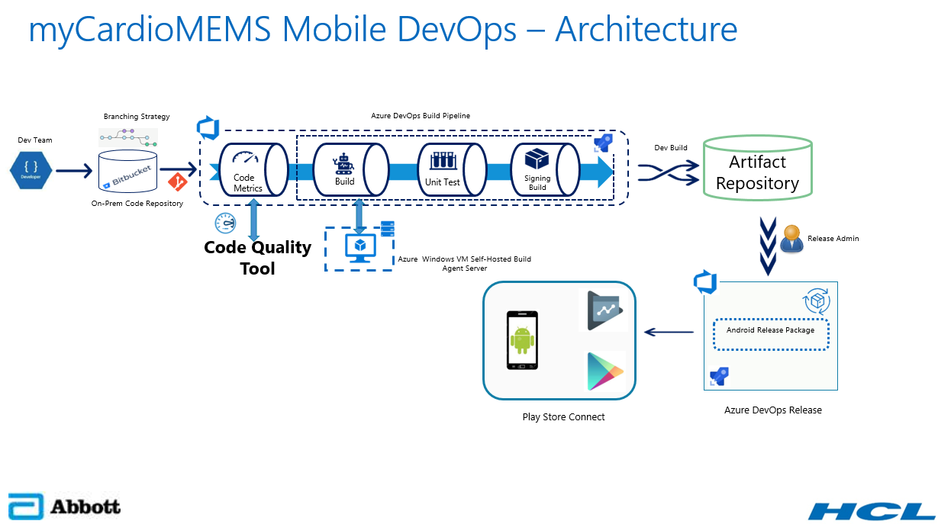

1. **Configure Windows VM as a Self-Hosted agent**

* Login to the VM using RDP with the following credentials

Username: testpocuser

Password:

* In the VM open web browser, sign into your Azure DevOps organization and navigate to the Agent pools tab.
* Azure DevOps URL: <https://dev.azure.com/ABT-HF-Software/HeartMate%20Touch>
* Choose Azure DevOps, **Organization settings**.

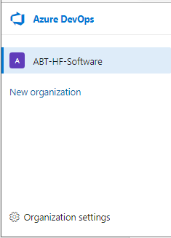

* Choose **Agent pools**.

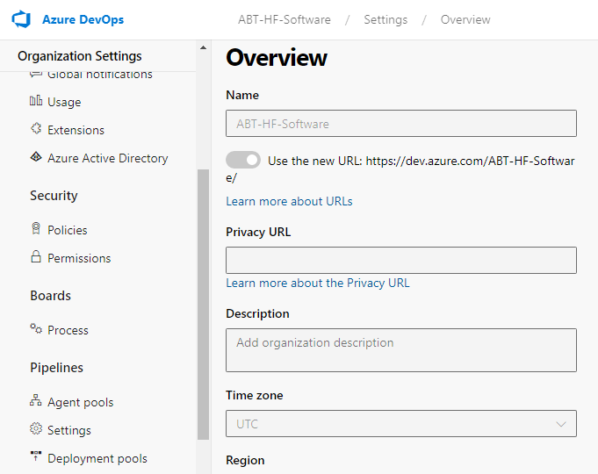

* Select the **Default pool**, select the Agents tab and choose **New agent**.
* On Get the agent dialog box, choose **Windows** and **Download** agent.

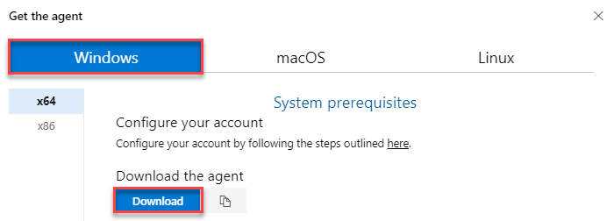

* Make a directory in C Drive with the name **Agent** and extract the downloaded agent zip file to this directory.

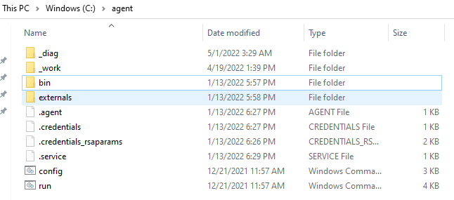

* Open PowerShell in administrator mode. Change the path to C:\AzAgent and type **Config.cmd** and hit Enter.
* Provide the following details:
  + Enter server URL: Your Azure DevOps **Organization URL**
  + Authentication type: Press the enter key for **PAT** as the authentication type and paste the **PAT** in the next prompt.
  + Let us use the default options for the rest of the configuration. Press Enter for all prompts until the command execution completes.
  + Once the agent is registered, type **run.cmd** and hit Enter to start the agent.
* [Click here](https://docs.microsoft.com/en-us/azure/devops/pipelines/agents/v2-windows?view=azure-devops) for more information on how to configure the agent.

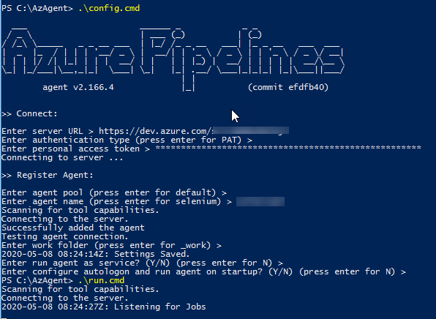

**10. Set up Build Pipeline:**

* Sign into your Azure DevOps organization and go to your project - [Summary - Overview (azure.com)](https://dev.azure.com/ABT-HF-Software/HeartMate%20Touch).
* Open your project and navigate to left panel click on **Pipelines** as in screenshot below.

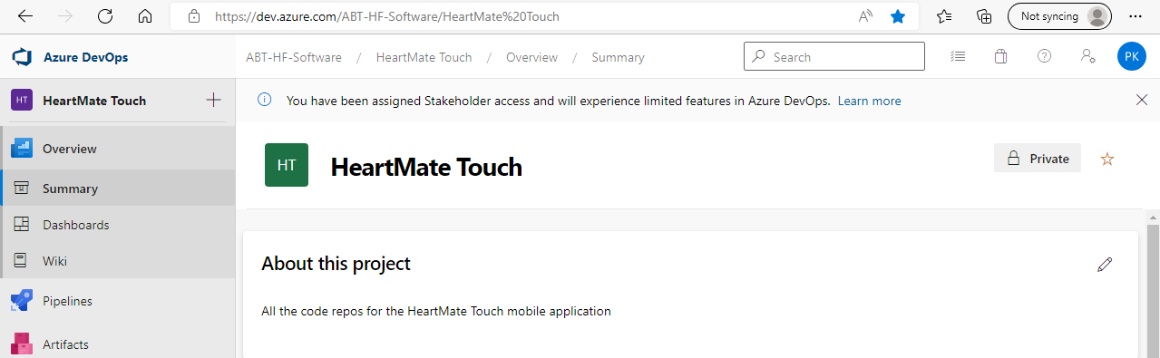

* Click on **New pipeline** which will open the below page.

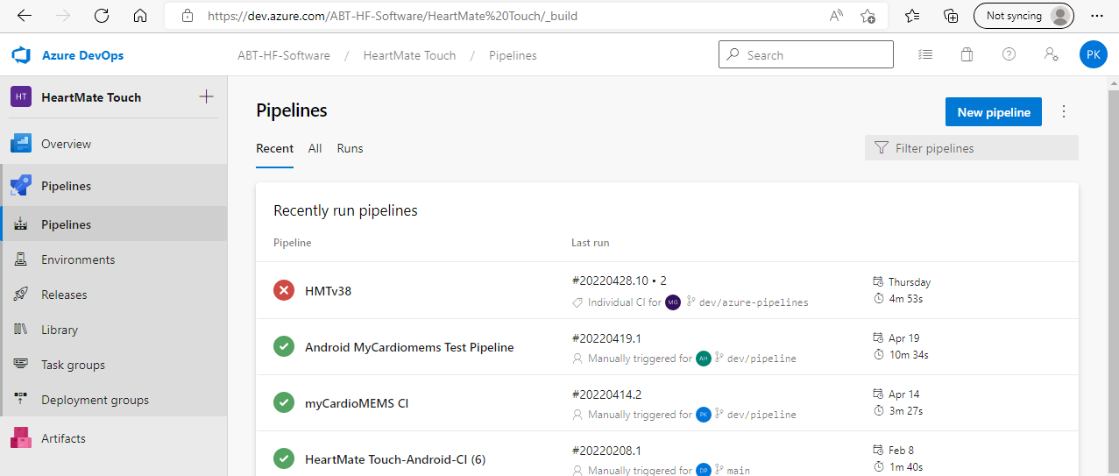

* Click on **Other Git** option.

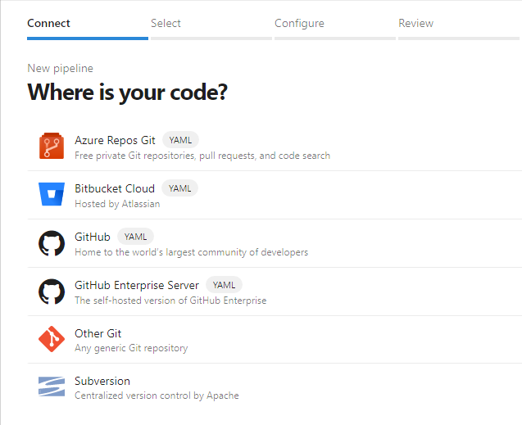

* Here we are going to select classic editor
* Click on **New service connection**.

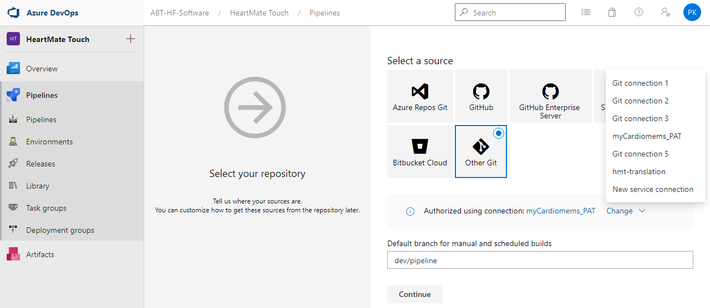

* Provide **Connection name Bitbucket URL, username and password/Token key**, press OK.

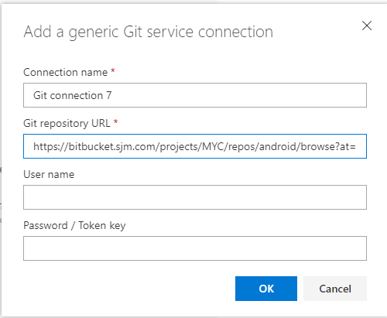

* Select the **Service connection** from the dropdown, provide the **Branch name** and Click on **Continue**.

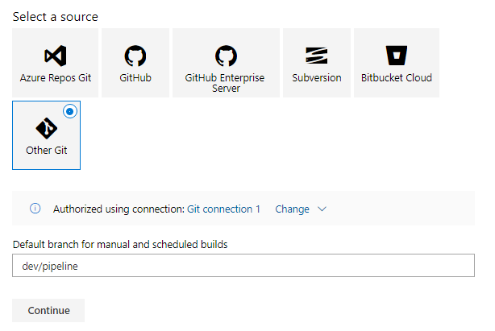

* Search for **Android** in the sear bar and click on **Apply.**

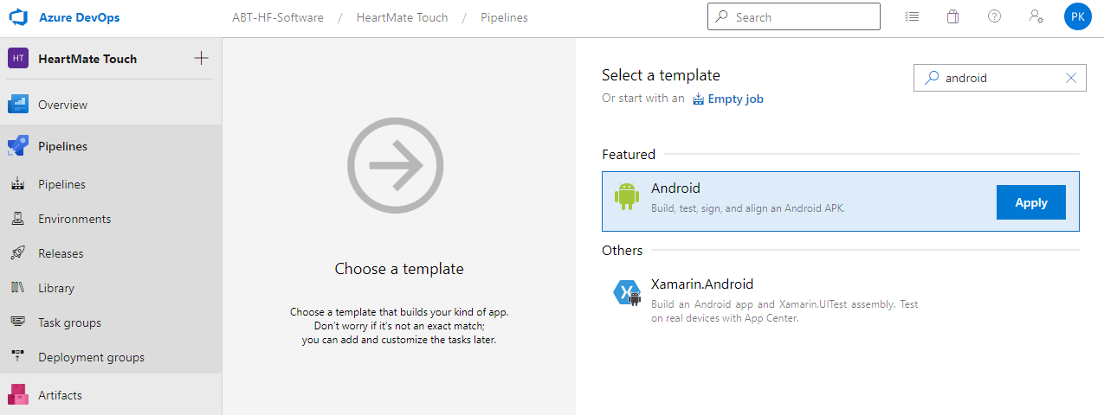

* Name the pipeline and select an agent from **Agent Pool.**

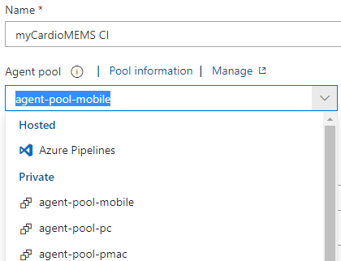

* Once we select Android, below tasks comes by default.

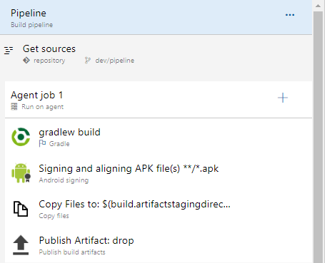

* Gradle Task: Build the myCardioMEMS Application and it will generate APK file
* Signing Task: sign the APK file.
* Copy Files Task: Copy the files from system.defaultworkingdirectory to build.artifactstagingdirectory.
* Publish Artifact Task: publish the artifact (APK) to drop.

**10.1 Gradle Task**

* To make a release build update task name to assembleRelease. to build using a particular flavor update your task name accordingly. e.g. if by using dev as a flavor name update your task name as assembledev.
* Turn off Publish to Azure Pipeline under JUnit Test Results section. keep it on as per the requirement.

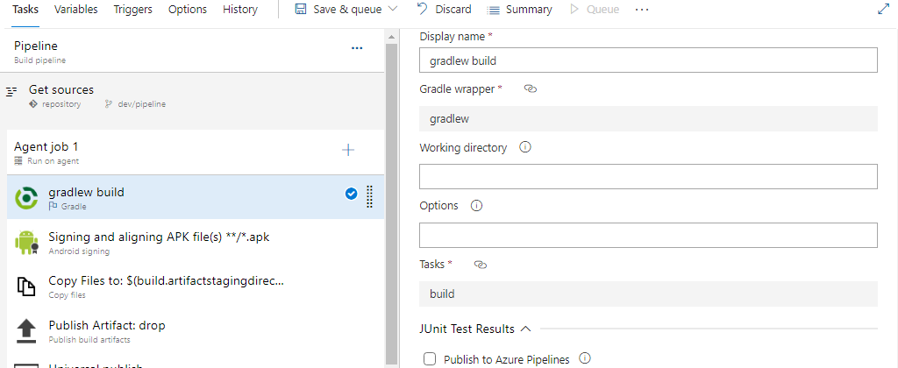

**10.2 Signing Task**

* Signing Task is required keystore file, StorePassword, KeyPassword and KeyStoreAlias follow the below steps to setup.
* By clicking on the **Gear icon** on the right side browse the Keystore file.

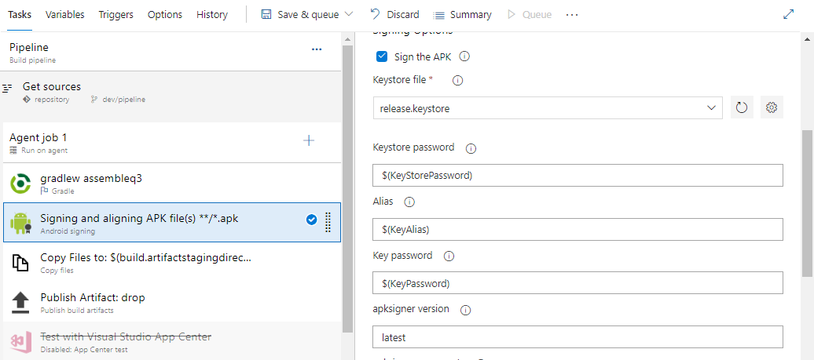

* **Browse** the Keystore file and click on **OK**, it stores in **Libariry-> Secure files**.

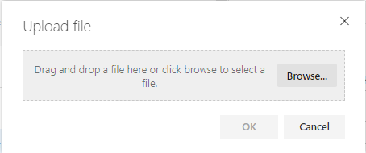

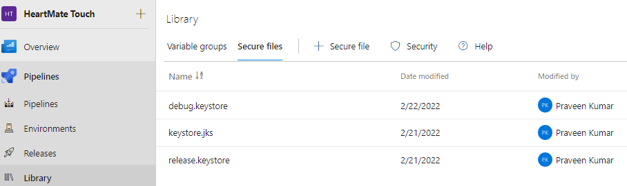

* Signing task need to provide StorePassword, KeyPassword and KeyStoreAlias.
* Already set KeyStoreFile.secureFilePath. Time to set other 3 variables StorePassword, KeyPassword and KeyStoreAlias.
* Navigate to the **Variables** tab on the tap and add the variables and their values as shown in the screenshot below.
* Once that the values are correct click on the lock icon to secure it. Once lock and save no one will be able to view.

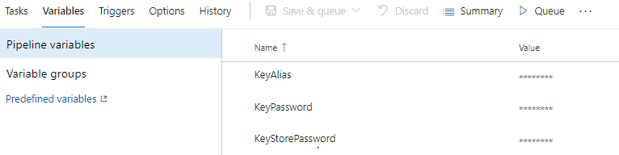

* Need to call the variable like below

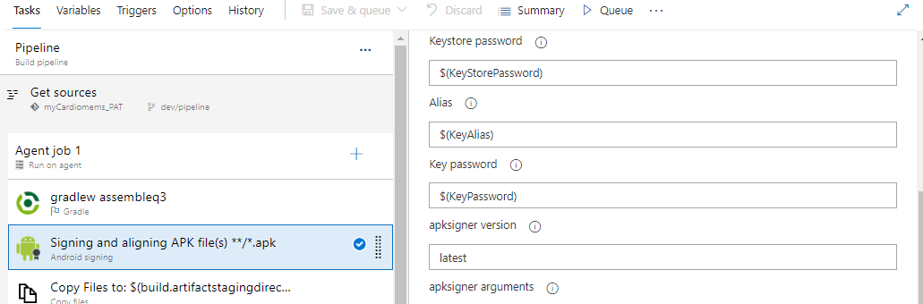

**10.3 Copy Files Task**

* Copy Files task copy \*\*/.apk file from $(system.defaultworkingdirectory) to $(build.artifactstagingdirectsory).

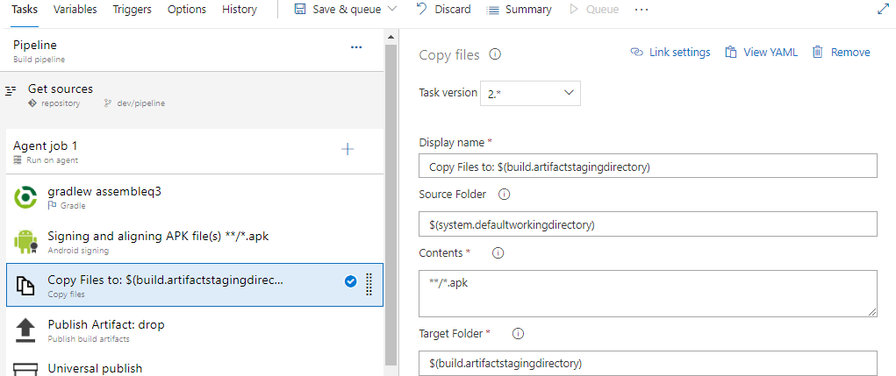

**10.4 Publish Artifact Task**

* Publish Artifact Task will publish the apk file from $(build.artifactstagingdirectory) to the drop.

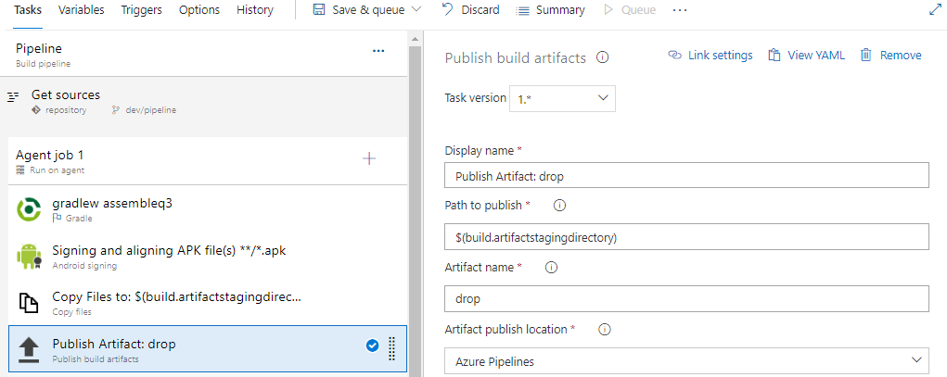

**10.5 Universal Publish Task**

* Universal Publish Task is used to upload the artifact (apk) to the Azure Artifacts (Artifactory Repository).
* Now add the tasks by clicking **+** button from Agent Job section.

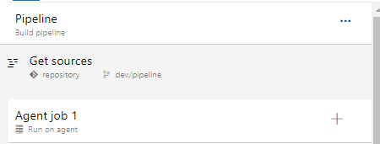

* Search for **Universal Packages** and click on **Add** button.

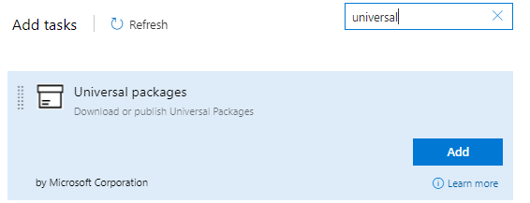

* Provide the **Display name**, select the **Publish** command from the dropdown.
* Provide the **Path to files to publish** as $(Build.ArtifactStagingDirectory).
* Select **Destination feed** from the dropdown - **Artifact.**
* Select the **Package name** from the dropdown - **my-first-package.**

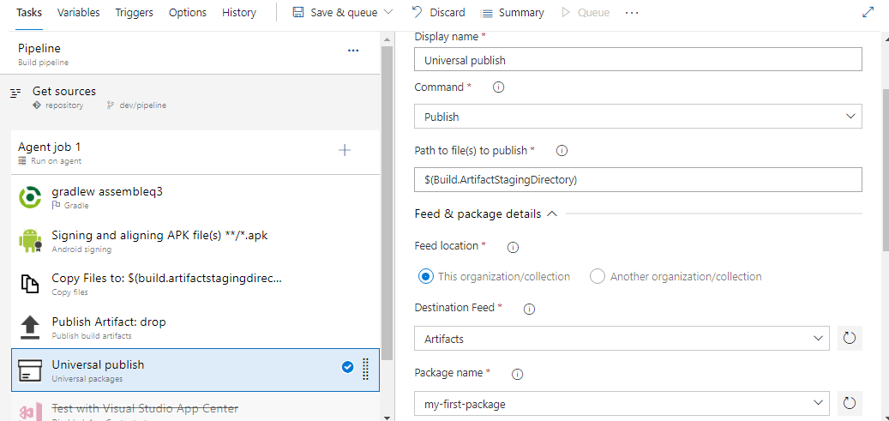

**11. To Run the Pipeline**

* Click on **Save & Queue**, Pipeline will start running.

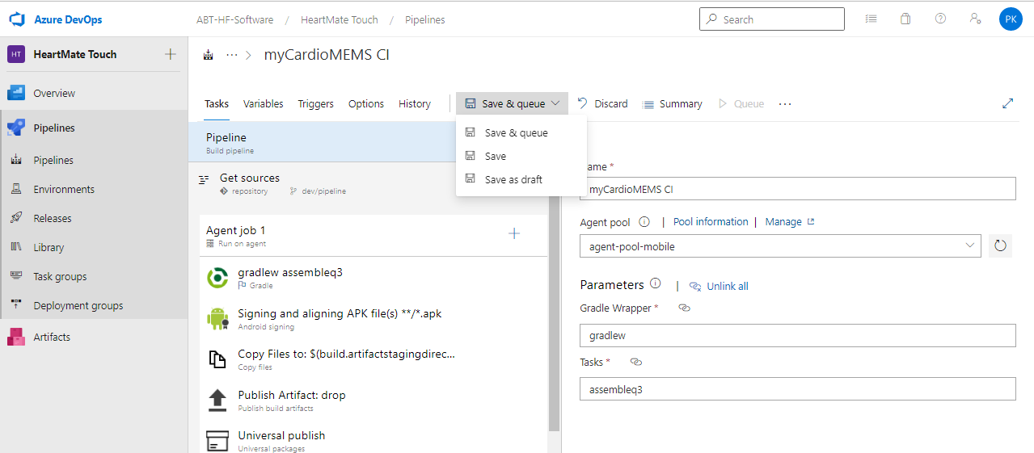

* Once the Pipeline completes it will generate apk file.
* To see the apk file click on **artifact**.

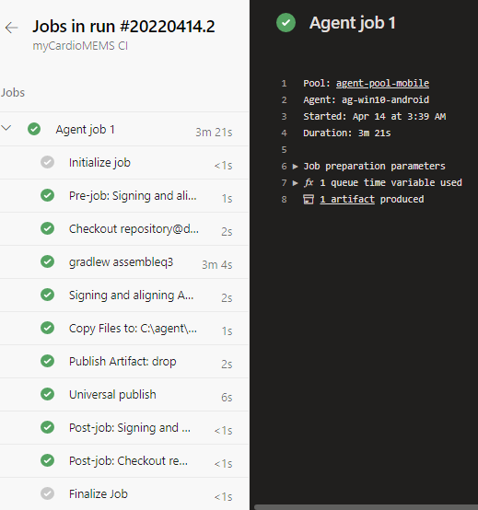

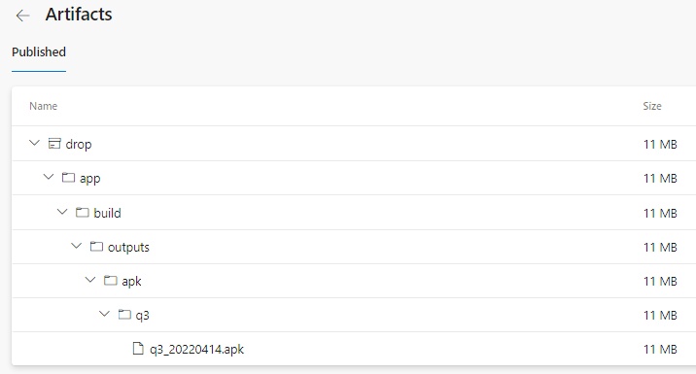

* To view the artifacts in Azure Artifacts. Click on the **Artifacts**, it will navigate package path.

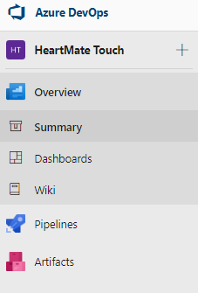

* Click on **my-firs-package**, it will show the list of **artifacts with version**.

